**BUSINESS REQUIRMENT:**

The company requirements are as follows:

* We have data available in csv format and its not in proper format
* Business wants to grow the business and for that we want you to clean the data and process and build certain KPI for the business.
* We have below two data sets
* Customer related data
* Product related data

**STEPS TAKEN**

* The data was imported into databricks.
* The dataset had no labels, so I created a column name for each of the files.
* Both files were joined for proper and relative analysis.
* On the Databricks, i carried out series of analysis to uncover the different trends on the dataset shown here: https://databricks-prod-cloudfront.cloud.databricks.com/public/4027ec902e239c93eaaa8714f173bcfc/1333937627440061/805040450503056/8336241901072640/latest.html
* Finally, on the databricks, visuals were made for better illustration. You can view the dashboard by following this link: https://community.cloud.databricks.com/?o=1333937627440061#notebook/805040450503056/dashboard/4182190268899718

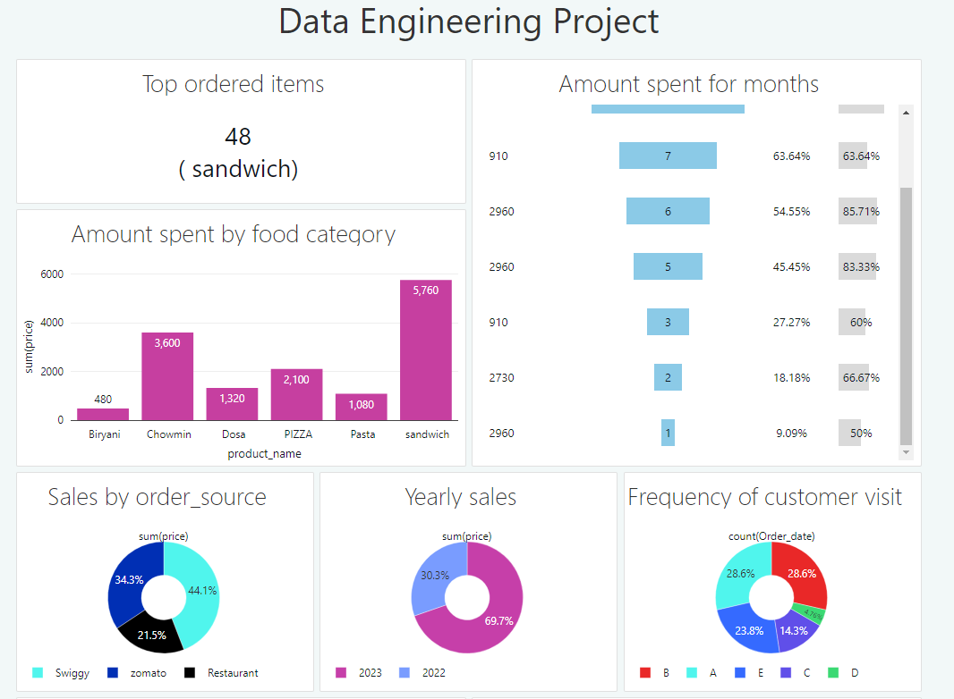**INSIGHTS GOTTEN FROM THE ANALYSIS**

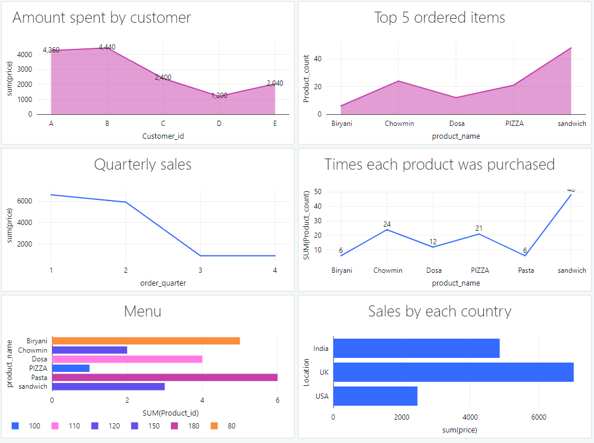

***fig 2: PowerBi dashboard***

From the analysis in figures above,

1) **Total Amount spent by each customer**: Customer A made the most spending.

2) **Total Amount spent by each food category**: From the category of foods, Sandwich made the most sales.

3) **Total Amount of sales in each month**: Sales were made more on the 7th month (July). It gained 63.34%.

4) **Yearly Sales**: More sales were made in 2023 than in 2022.

5) **Quarterly Sales:** Sales were made more in the first quarter.

**7) Top 5 ordered items**: The top five ordered items are: Biryani, Chowmin, Dosa, Pizza< Pasta and Sandwich in an ascending order.

8) **Frequency of customer visited:** Customer B visited more than the others.

9) **Total sales by each country**: UK made the most sales.

10) **Total sales by order source:** Restaurants made the most sales.